Picnic on Titan
Ethane lakes in a red haze: Titan's uncanny moonscape

11 July 2011 by Jeff Hecht Magazine issue 2820.
Reproduced with kind permission of New Scientist Magazine.

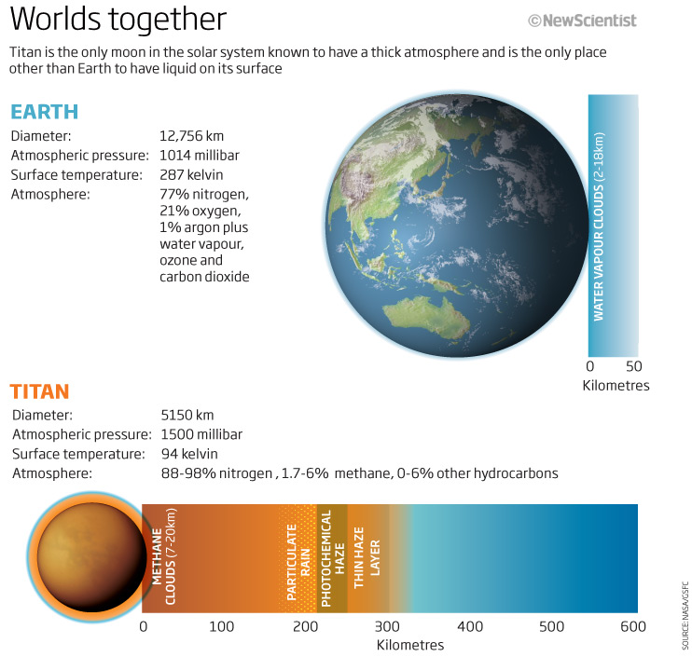

Skies like a bad day in LA, red-and-black rainbows, Mississippi-style river channels – Saturn's largest moon is our prototype weird-world exoplanet Summertime is on its way. A thick smog hangs in the air. Storms are on the move, bringing rare rains to dry areas, and elsewhere lakes are shrinking. Only this is not Earth. This is the view on Saturn's largest moon, Titan, more than a billion kilometres away.

We knew very little about this strange world before NASA's Cassini spacecraft arrived at Saturn seven years ago. Since then, the ringed planet has completed a quarter of an orbit around the Sun and Titan has passed through its spring equinox. In that time, Cassini has swooped by Titan almost 80 times and has released the Huygens lander onto its surface.

Together they have penetrated the haze that hides Titan's surface to reveal modest mountains, vast fields of sand dunes, rocks, and even streams, lakes and weather.

Titan looks surprisingly familiar, although it is a cold, dimly lit world made from unfamiliar materials, says planetary scientist Elizabeth Turtle of Johns Hopkins University Applied Physics Laboratory in Baltimore, Maryland. "The rocks are water ice and the lakes are methane and light hydrocarbons, yet we see processes very similar to what we see on Earth."

So far, there are no recognisable signs of organic life. That's not surprising: by terrestrial standards, Titan is a deep freeze with surface temperatures at a chilly -180°C. Yet Titan is very much alive in the sense that its atmosphere and surface are changing before our eyes. Clouds drift through the haze and rain falls from them to erode stream-like channels draining into shallow lakes. Vast dune fields that look as if they were lifted from the Sahara sprawl along Titan's equator, yet the dark grains resemble ground asphalt rather than sand. It is a bizarrely different world that looks eerily like home. Or as planetary scientist Ralph Lorenz puts it: "our prototype weird-world exoplanet".

By exploring Titan, we can hope to understand more about planets around other stars. NASA's Kepler telescope has found over 1200 possible exoplanets and we would dearly love to find out what these worlds are like. So far our understanding of geological processes, such as how the landscape is sculpted by winds and waves, is based on empirical evidence from just one planet - our own. That means any explanation of the underlying processes either on other planets or on a changing Earth are beyond us. "If we can test theories on both Earth and Titan, we can be much more confident in extending these theories to other conditions," says Lorenz, who is also at Johns Hopkins.

What an atmosphere
Titan was discovered in 1655 by Christiaan Huygens. At about 5150 kilometres across, it is slightly larger than the planet Mercury and a touch smaller than Jupiter's largest moon Ganymede. But what sets it apart from other large moons is its atmosphere, discovered in 1944 by Gerard Kuiper. Wisps of gas surround some satellites, but Titan's atmosphere is the real thing - and is many times thicker than Earth's.

This atmosphere made Titan a uniquely tempting target when spacecraft began exploring the solar system. Pioneer 11 took the first snaps in September 1979 and Voyager 1 travelled within 22,000 kilometres of Titan a year later. The results were spectacular, but disappointing: a beautiful high-altitude blue haze hanging over a thick orange haze that obscured the surface. NASA and the European Space Agency soon began planning the Cassini mission to get a closer look.

Cassini finally arrived in 2004, after a seven-year journey from Earth, and released the Huygens lander. This transmitted images and data for 2.5 hours as it descended through Titan's murky atmosphere and for 1.5 hours after landing. Cassini has continued to monitor Titan ever since, flying past as low as 880 kilometres above its surface. With each pass, Cassini reveals a little more about the only body in the solar system besides the Earth known to have liquid on its surface.

The picture we have built up is intriguing. Like Earth's atmosphere, Titan's is largely nitrogen plus one more-reactive compound and some trace gases (see diagram). Titan's weaker gravity lets its atmosphere extend far higher than on the Earth, with the stratosphere starting at 40 kilometres and reaching up to a few hundred kilometres.

Standing on Titan, you would see a dense orange haze similar to a really bad smog day in Los Angeles. It comes from the same basic process, too - photochemical reactions in the air. LA's smog is caused by sunlight driving chemical reactions between oxygen, nitrogen compounds and hydrocarbons in the lower atmosphere. On Titan the photochemistry starts at the top of the atmosphere, about 1000 kilometres up, where energetic ultraviolet photons from the Sun and cosmic rays trigger reactions among methane and nitrogen molecules. That produces hydrocarbons and cyanide compounds, which drift downwards and react further to produce a poorly understood group of complex compounds called tholins. Carrie Anderson, who is trying to pin down the composition of these compounds by reproducing them at NASA's Goddard Space Flight Center, calls them "gunk".

Tholins aggregate into aerosols that settle slowly into the lower atmosphere, forming a thick layer that blocks solar ultraviolet and affects air circulation and the weather. The particles continue growing and eventually settle on the surface, where they are stable in Titan's nitrogen-methane atmosphere. Tholins may have rained down on the early Earth as well, but they haven't been stable here since oxygen became common more than 2 billion years ago and destroyed them.

How Titan sustains such an atmosphere remains a mystery. Photochemical reactions would deplete the methane in Titan's atmosphere within 15 million years, so something must be replacing the destroyed gas. Vents, geysers or volcanoes could be belching out methane from inside the moon, and Cassini's radar has spotted landforms that might be icy volcanoes. "It seems unlikely the releases of methane are perfectly timed to match photochemical depletion," says Lorenz. Surplus methane could have changed Titan's climate, not least because methane can condense and fall as rain on this chilly world. Giant sporadic releases of methane could mean that Titan is a much wetter place from time to time.

Before Cassini, we expected Titan to be covered with large lakes. However radar observations have shown that lakes cover only a few per cent of the surface and are concentrated near the poles, making Titan much drier than Earth. Yet Cassini has also spotted channels leading into these wet areas, which look as though they were carved by rivers. Still, Turtle has seen no evidence of year-round rivers, suggesting Titan might resemble the deserts of the US Southwest, where river channels are dry most of the year but carry water during rare rains. Or it could mean the moon was wetter in the past.

Alien weather
Even though we have not seen it directly, Cassini has given us tantalising evidence of rain. Last September, the orbiter studied the equatorial zone, where large sinuous channels wind near dune fields. On previous fly-bys, this region had been covered with clouds. This time, images showed that large areas near the dunes had darkened. A few weeks later, another fly-by revealed that much of the surface had returned to normal. The findings led Turtle's group to report that methane rain - dubbed "April showers" by the team - had soaked the area and the fluid had evaporated or soaked into the ground (Science, vol 331, p 1414).

"Raindrops on Titan presumably look much like raindrops on Earth," Turtle says. But with Titan's weaker gravity, the drops might grow larger and fall more slowly. Many could evaporate as they pass through the dry lower atmosphere and never reach the surface.
If we were to visit Titan, though, rainy days would be very different from those on Earth. For a start, the thick haze blocks most sunlight from reaching the surface. Only longer, red wavelengths would illuminate the landscape. If sufficient sunlight reached falling droplets of methane to make a rainbow, it would appear as a series of red and dark bands.

Now the seasons are changing on Titan as Saturn continues its 29.5 year orbit around the Sun. "We are seeing meteorological activity at low latitudes and we expect it to move to high latitudes," says Turtle. Again the spotlight will be on Titan's lakes.

The lakes pose their own puzzles, starting with how much liquid they contain. "It's hard to constrain the depths of the lakes because we're just seeing the surface," says Turtle. A few clues come from sprawling Ontario Lacus in the south, which has shrunk several kilometres in some areas since Cassini's arrival. Oded Aharonson's group at the California Institute of Technology in Pasadena estimates the lake level is dropping by about a metre every terrestrial year, suggesting part of the lake bed must be very flat.

What makes Titan's equivalent of the water cycle so complex is the blend of hydrocarbons in the lakes. That too is something of a mystery. Cassini has identified ethane in Ontario Lacus, and methane is almost certainly present. Methane rain should fall on the lakes but it is vastly more volatile than ethane and propane, so it probably evaporates much faster from lakes, leaving the heavier hydrocarbons behind. Still, confirming this is difficult, says Turtle, "because there's so much methane in the atmosphere and so many hydrocarbons coating everything".

Perhaps the best estimate so far comes from Daniel Cordier of the University of Rennes 1 in France, whose computer model incorporates Cassini observations and chemical data to show that three-quarters of an average polar lake is ethane, with 10 per cent methane, 7 per cent propane and smaller amounts of hydrogen cyanide, butane, nitrogen and argon. "The chemical composition probably varies from one particular lake to another," says Cordier, though his model is too simplistic to see such differences. That's likely to mean lake-to-lake variations in properties like viscosity. Some might end up as tarry as the Great Salt Lake in Utah is salty.

The changing seasons could solve another mystery. Were you to stand on the shores of one of Titan's lakes, you would see it was as calm as a millpond. "We haven't seen any evidence of waves," Turtle says. That's puzzling because mixtures of methane and ethane should be less viscous than water, meaning that even light winds can whip up waves. Yet the lakes are eerily flat, to within millimetres.

Last year, Lorenz calculated that wind speeds of less than 1 metre per second - calm by terrestrial standards - should be sufficient to produce detectable waves in an ethane lake. The fact that we haven't seen any points either to viscous lakes containing heavier hydrocarbons, as Cordier suspects, or an almost windless Titan. Lorenz's work also suggests that the wind speeds should pick up as the seasons change, so we may just need to wait for the answers.

The hydrocarbon lakes are part of a landscape that exhibits both the general principles of geology and the different ways they work on other worlds. On Earth, lakes and ponds are tied to aquifers, layers of permeable rock that can store water. So might hydrocarbons permeate Titan's rock-ice, linking its methane-ethane lakes to "methanofers"? Lakes near the north pole have not changed in years of observations, Turtle says. Those in the south, in contrast, show some evaporation at times, implying that they are sitting on impermeable layers. Perhaps the northern lakes do not drain away because they are in contact with larger reservoirs of ground methane.

Perhaps the most striking similarity between Earth and Titan was presented earlier this year at the Lunar and Planetary Science Conference in The Woodlands, Texas. Mike Malaska is an organic chemist whose day job is drug discovery for a small pharmaceutical company but whose passion has become exploring Titan's surface. Malaska works as a volunteer for the Cassini team in his spare time and at the conference he described a winding channel flowing into a south Titan lake that follows a path very similar to a stretch of the lower Mississippi river - and thus might carry a comparably vast flow after a methane rain.

Even Titan's rocks have that mix of sameness and difference. They are made of water ice, which on the frigid satellite should be about as resistant to erosion as terrestrial minerals. Pictures from Huygens show cobbles of ice that resemble water-worn rocks on a terrestrial stream bed.

The same goes for the sand dunes that cover about 20 per cent of Titan's surface. They appear uncannily alike in size and shape to dune fields in the Sahara, Namibia and Saudi Arabia. "The dunes were a surprise to everyone," says Jani Radebaugh of Brigham Young University in Provo, Utah. Dunes form on Earth when suitable winds scatter sand-sized grains - usually quartz, gypsum or basalt - across the surface, creating ridges that grow to enormous sizes. The grains need to be a particular size, but not a particular composition.

On Titan, the grains are composed of tholins from the hazy atmosphere, which according to models and observations of the dunes' shape, are blown by strong winds when the Sun is over the equator. Radebaugh thinks the compounds formed layers on the surface possibly in much the way that carbonates form limestone layers in shallow Earth seas. Methane rains then eroded these layers, forming sand-sized particles. In the absence of any mission to bring back samples from Titan, Radebaugh says laboratory studies are needed to determine the particles' interaction with methane-based fluids, how they create landforms, and to work out their composition.

The Cassini team hopes that many of Titan's puzzles will be solved as Saturn journeys around the Sun. "Hopefully the mission will extend to the northern summer solstice in 2017," says Turtle. That would cover seasonal changes in climate, lakes and atmospheric circulation vital to understanding Titan as a whole.

And plans are already afoot for a follow-on mission called the Titan Mare Explorer (TiME), which NASA could launch in 2016. The probe is destined to splash down on one of the largest bodies of liquid so far identified on Titan, a 10,000-square-kilometre hydrocarbon sea called Ligeia Mare. It would spend three to six months cruising the northern lake, analysing its composition and exploring the vicinity.

By then we will have confirmed the existence of many more planets around other stars. Some of them will have thick atmospheres; all will be too distant for us to travel to any time soon. Yet thanks to what we'll have learned from Titan, these strange worlds may not be so alien after all.

